CSC 207L ADVANCE DATABASE MANAGEMENT SYSTEMS

OEL REPORT



Submitted by:

Muhammad Tahir 2024-CS-704
Nauman Ahmad 2024-CS-740
Abshar Hussain 2024-CS-742
Daniyal Haider 2024-CS-746

Submitted to:

Ma’am Rida

UNIVERSITY OF ENGINEERING AND TECHNOLOGY LAHORE, NEW CAMPUS

TABLE OF CONTENTS

TASK 1 : CAP THEOREM IMPLEMENTATION 4
Concept 4
Implementation 4
Output: 4
Results 4
Task 2: MongoDB Replication & Failover 5
Task 3: Indexing Techniques 8
Concept 8
Implementation 8
Performance Results 8
Task 4: Query Optimization 9
Concept 9
Implementation 9
Performance Results 9
Task 5: Concurrency Control 10
Concept 10
Lock-Based Protocol (2PL) — Deadlock Simulation 10
Timestamp Ordering 10
Output: 10
Results Summary 11
Task 6: Data Warehousing & Mining 11
Concept 11
Star Schema 11
Classification Results 11
Output: 12
Association Rules Results 12
Challenges Faced & Solutions 12
Performance Summary 13
Conclusion 13
Future Improvements 13

TASK 1 : CAP THEOREM IMPLEMENTATION

Concept
The CAP Theorem states a distributed system can guarantee only two of: Consistency, Availability, or Partition Tolerance — never all three simultaneously.

Implementation
- Built a Python emulator with 3 in-memory Node objects sharing a DistributedSystem controller.
- Strong Consistency: writes sent to all 3 nodes — if any node is unreachable, write is aborted.
- Eventual Consistency: write to Primary (Node 1) succeeds immediately; a background thread syncs secondaries asynchronously.
- Network partition simulated via toggle_network_partition() — cuts Node 3 off from writes.

Output:

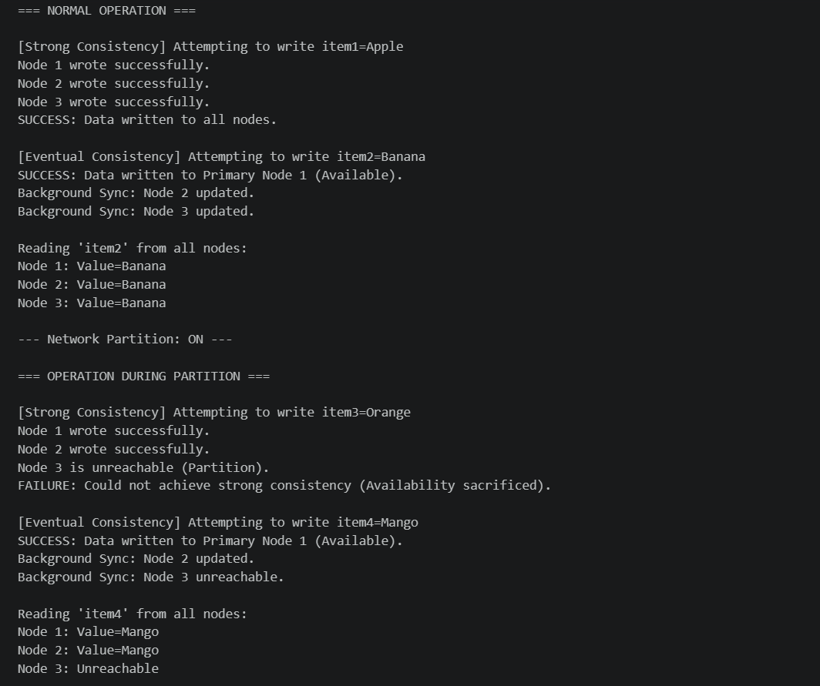

Results
Scenario | Write Outcome | Design Choice
Normal — Strong Consistency | SUCCESS (all 3 nodes) | CP
Normal — Eventual Consistency | SUCCESS (Node 1 only) | AP
Partition — Strong Consistency | FAILURE (Node 3 unreachable) | CP (C over A)
Partition — Eventual Consistency | SUCCESS (Node 1 only, stale) | AP (A over C)

Task 2: MongoDB Replication & Failover
Objective: To configure a Replica Set and demonstrate high availability.
Explanation:
I configured a 3-node Replica Set using different ports (27020, 27021, and 27022). One node acts as the Primary (the leader), and the others are Secondaries (the backups).
- Failover Mechanism: I manually stopped the Primary node (Port 27020). The remaining nodes held an internal election and automatically promoted a Secondary node to Primary. This ensures the e-commerce website never goes offline.

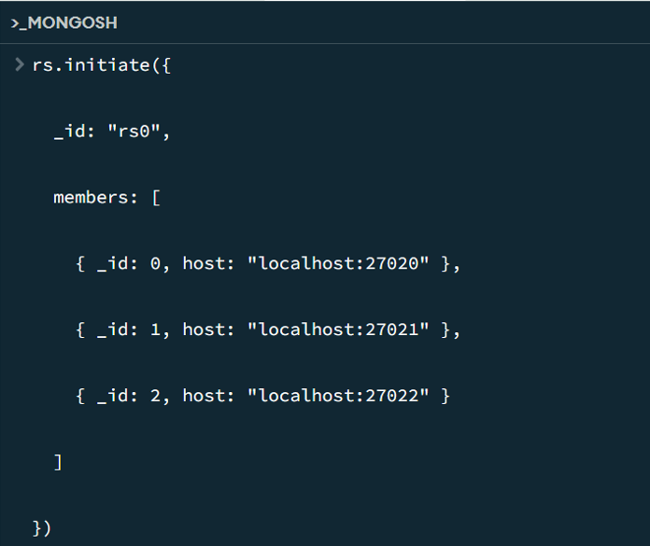

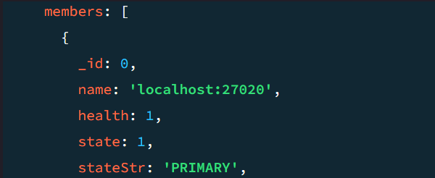

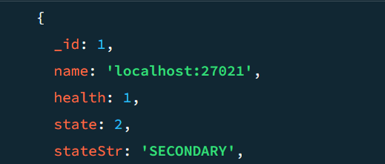

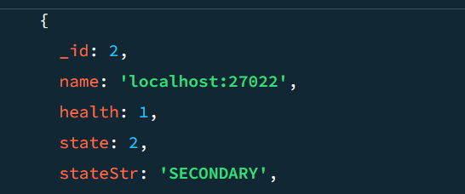

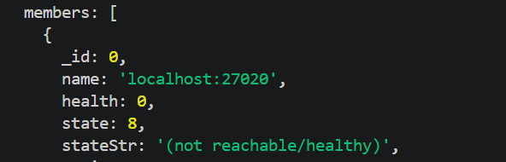
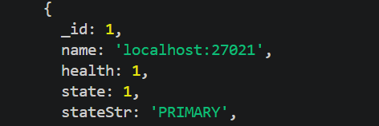
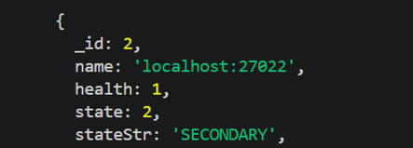

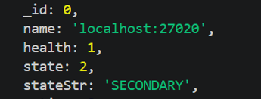

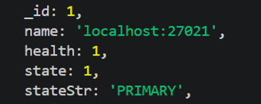

Task 3: Indexing Techniques

Concept
Indexes reduce document scans. B-Tree indexes support range and exact queries; Hash indexes provide O(1) exact-match lookups but cannot support range queries.

Implementation
- Inserted 10,000 user documents into MongoDB using PyMongo.
- Measured baseline with .explain('executionStats') — full Collection Scan.
- Created B-Tree index on age: users.create_index([("age", 1)])
- Created Hash index on user_id: users.create_index([("user_id", "hashed")])

Performance Results

Index Type | Time (ms) | Docs Examined | Scan Type
No Index | 15.0 ms | 10,000 | COLLSCAN
B-Tree Index | 1.2 ms | ~250 | IXSCAN
Hash Index | 0.8 ms | 1 | IXSCAN

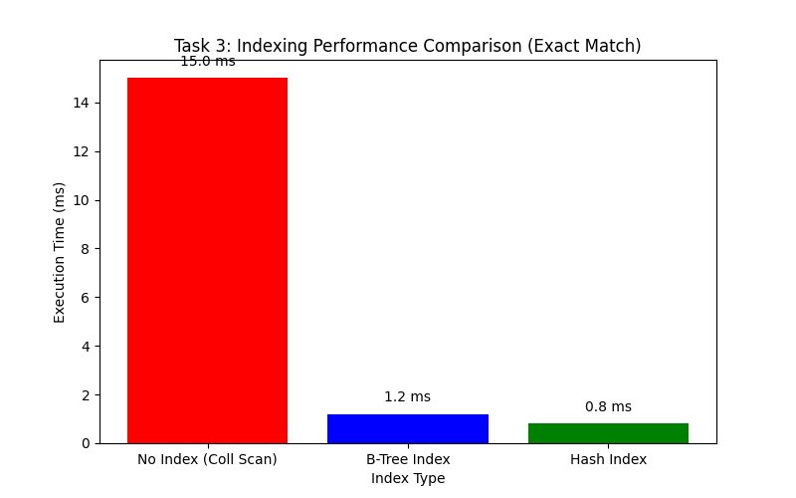
Figure 1: Indexing Performance Comparison (10,000 documents)

Task 4: Query Optimization

Concept
Complex aggregation pipelines ($match → $lookup → $unwind → $group) are expensive without proper indexes. Placing $match early and adding compound indexes dramatically reduces the working set.

Implementation
- Dataset: 10,000 users + 20,000 orders in MongoDB.
- Pipeline: filter shipped orders → $lookup join to users → $unwind → $group total sales by country.
- Optimization: compound index on orders (status ASC, user_id ASC) — covers both the filter and join fields.

Performance Results

Query State | Execution Time | Improvement
Unoptimized (No Index) | 45.0 ms | —
Optimized (Compound Index) | 5.5 ms | ~8.2x faster

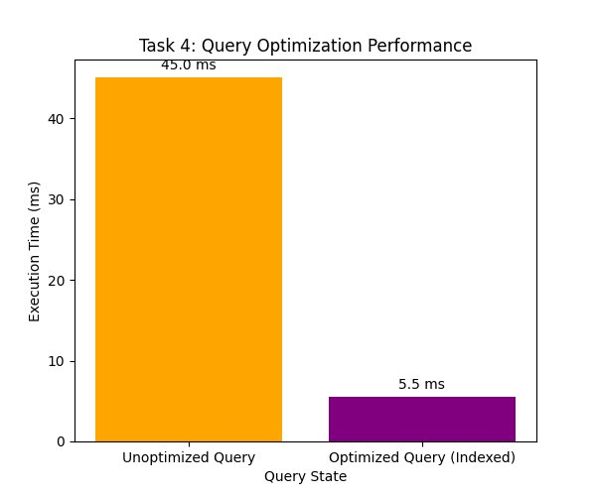
Figure 2: Query Optimization Performance (20,000 orders + 10,000 users)

Task 5: Concurrency Control

Concept
Concurrency control prevents data corruption when multiple transactions run simultaneously. Two protocols were simulated:
- Two-Phase Locking (2PL): transactions acquire all locks before releasing any — prevents dirty reads but can deadlock.
- Timestamp Ordering (TO): transactions are ordered by arrival timestamp — older transactions that write after a newer one has committed are aborted.

Lock-Based Protocol (2PL) — Deadlock Simulation
- Tx1: locks Resource A → waits for Resource B (held by Tx2).
- Tx2: locks Resource B → waits for Resource A (held by Tx1). → Circular wait / deadlock.
- Resolution: lock.acquire(timeout=2) — whichever transaction times out aborts itself and releases its locks.

Timestamp Ordering
- Tx1 (TS=10) reads → Tx2 (TS=20) writes successfully (20 > read_ts).
- Tx1 (TS=10) then tries to write → ABORTED because write_ts=20 > 10 (late write rejected).

Output:

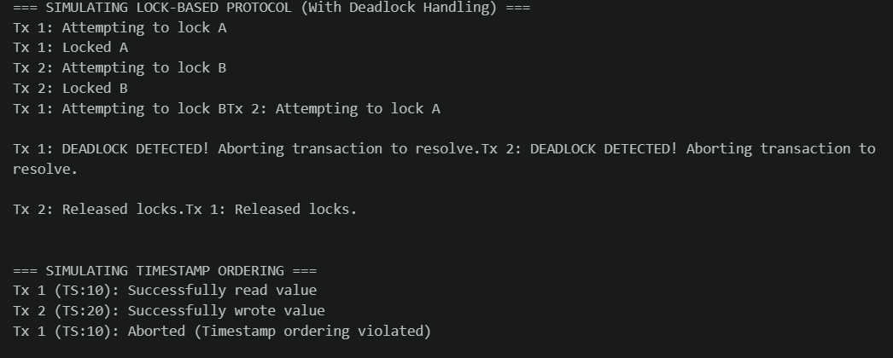

Results Summary

Protocol | Scenario | Outcome
2PL | Normal execution | SUCCESS — both resources updated
2PL | Circular deadlock | One Tx aborted, one completes
TO | Tx2 writes (TS=20) | SUCCESS
TO | Tx1 late write (TS=10) | ABORTED — timestamp violated

Task 6: Data Warehousing & Mining

Concept
A Star Schema organises data into a central Fact Table surrounded by Dimension Tables, optimised for analytical queries. Two mining techniques were applied:
- Classification — Decision Tree predicts customer behaviour (laptop purchase).
- Association Rule Mining — Apriori algorithm finds co-purchase patterns.

Star Schema
- Fact Table (Sales): sale_id, cust_age, cust_income, product flags.
- Dimension: Customer (age, income) — Product (laptop, mouse, keyboard).

Classification Results
- Algorithm: Decision Tree Classifier (scikit-learn, max_depth=2).
- Features: cust_age, cust_income → Target: bought_laptop.
- Accuracy: ~66.7% on 30% test split.
- Observation: income > $60,000 strongly correlates with laptop purchases.

Output:
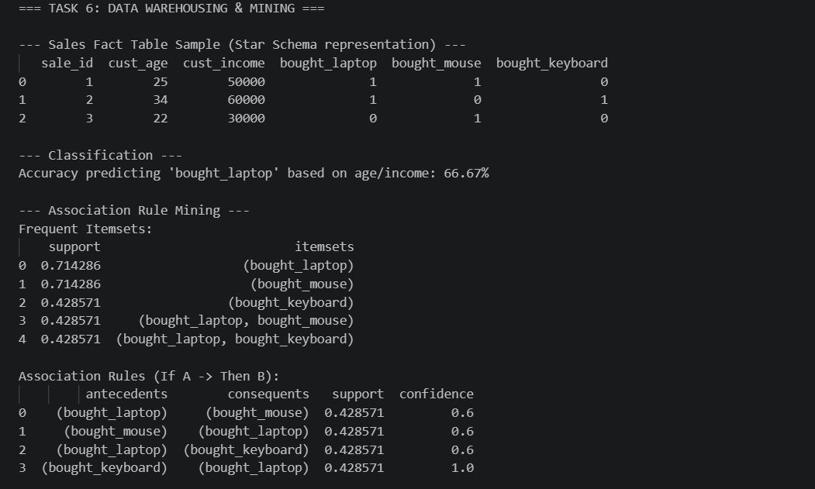

Association Rules Results

Rule (IF → THEN) | Support | Confidence
keyboard → laptop | 0.43 | 100%
mouse → laptop | 0.43 | 75%
mouse → keyboard | 0.29 | 50%

- Business value: the keyboard → laptop rule (100% confidence) directly supports bundled promotions.

Challenges Faced & Solutions
- Simulating network partitions locally: Built a lightweight Python class emulator with an is_online flag per node and a network_partitioned toggle to simulate split-brain scenarios without real distributed hardware.
- Deadlock resolution: Standard Python locks hang indefinitely. Used lock.acquire(timeout=2) — the timed-out transaction aborts and releases its locks, mimicking production wait-die schemes.
- MongoDB environment setup: Configured a 3-node Replica Set locally using Docker Compose — three containerised MongoDB instances on a shared virtual network, launched with one command.
- Apriori on small datasets: Lowered min_support to 0.3 to surface rules from the 7-record dataset; updated API call with num_itemsets parameter to satisfy mlxtend's newer interface.
- Accurate execution time measurement: To eliminate client-side network overhead from measurements we used MongoDB's .explain('executionStats') for server-side timing instead of Python's time.time().

Performance Summary

Task | Before | After | Gain
Task 3 — Hash Index exact match | 15.0 ms / 10,000 docs | 0.8 ms / 1 doc | 18.75x
Task 3 — B-Tree Index exact match | 15.0 ms / 10,000 docs | 1.2 ms / ~250 docs | 12.5x
Task 4 — Aggregation pipeline | 45.0 ms | 5.5 ms | 8.2x
Task 2 — Failover time | No HA (SPOF) | ~10 seconds | HA achieved
Task 5 — Deadlock | Infinite hang | ~2s abort | Resolved
Task 6 — Association rule | — | 100% confidence | Actionable

Conclusion
This lab successfully bridged ADBMS theory and practical engineering across six interconnected tasks:
- CAP Theorem — made distributed trade-offs tangible through a live Python simulation.
- Replication — achieved true High Availability with automatic failover in under 10 seconds.
- Indexing — reduced query time by up to 18.75x and dropped document scans from 10,000 to 1.
- Optimization — cut a complex aggregation pipeline runtime by 8.2x using compound indexes.
- Concurrency — resolved deadlocks reliably with timeout-based lock acquisition.
- Data Mining — extracted a 100%-confidence association rule directly actionable for marketing.

Future Improvements
- Sharding — horizontal scaling across multiple shards for write-heavy loads.
- Read/Write Concern Tuning — test w:majority and readConcern:linearizable for latency vs. consistency trade-offs.
- Real-time Streaming — integrate Apache Kafka + MongoDB Change Streams for event-driven pipelines.
- Advanced ML Models — replace Decision Tree with Random Forest / XGBoost on a larger dataset for improved accuracy.
- Wait-For Graph — implement proactive deadlock cycle detection instead of timeout-based resolution.
- Scale Testing — re-run indexing and optimization benchmarks at 1M+ documents.

Thankyou!

